THE PAPER PLANE CHALLENGE
Part A — Design
1. Construction of the Paper Airplane
- Material: One standard A4 sheet of paper.
- Reference: YouTube tutorial.
- The airplane was constructed by following the folding instructions in the tutorial.
- The paper was folded to form the nose, central body, and wings.
- The folds were pressed firmly, and the wings were aligned for balanced flight.
- No tape, glue, or paper clips were used.
2. Wing Shape, Dimensions, and Configuration
Wing shape and configuration
- The airplane has a pointed nose, narrow central body, and folded wings.
- The streamlined body may help reduce drag.
- The wings generate lift, while their alignment influences balance and stability.
Dimensions
- Paper size: A4 (29.7 cm × 21 cm).
- Wingspan and body length: To be measured on the completed airplane.
Reasons for choosing the design
- Its flight performance depends on wing shape, balance, and stability.
- Flight trials will determine its suitability for maximum airtime.
Part B — Aerodynamics
1. How Does the Airplane Generate Lift?
As the airplane moves forward, air flows around its wings. The wing shape and angle influence airflow and pressure distribution, producing an upward force called lift. The wings also deflect air downward, contributing to lift.
2. Lift, Weight, Drag, and Thrust
- Lift: Aerodynamic force that supports the airplane against gravity.
- Weight: Downward force due to gravity.
- Drag: Force opposing the airplane’s motion through air.
- Thrust: The initial forward push provided by the hand during launch.
During launch, the hand gives the airplane speed. After release, there is no sustained propulsion. During the glide, the airplane uses its initial energy while lift supports it and drag and gravity contribute to its gradual descent.
3. Wing Area, Wing Loading, Centre of Gravity, and Stability
- Wing area: Larger wing area can help generate sufficient lift at lower speeds.
- Wing loading: Weight divided by wing area. Lower wing loading generally supports slower flight.
- Centre of gravity (CG): The point where the airplane’s weight can be considered to act. Its position affects balance and pitching behaviour.
- Stability: The ability to maintain or return toward balanced flight. Correct CG position and aligned wings help achieve stable flight.
4. Why Might This Design Stay Airborne Longer Than a Conventional Dart?
A design with suitable wing area, low wing loading, and good stability may descend more slowly than a conventional dart. However, the selected tutorial’s design is associated with long-distance flight, so longer airtime is not guaranteed and must be tested.
- Minimum sink rate: The slowest rate of losing height; important for staying airborne longer.
- Maximum glide distance: The greatest horizontal distance travelled before landing; it does not necessarily mean the longest flight time.
Therefore, the best design for this challenge is the one that achieves the greatest average flight duration during repeated trials.
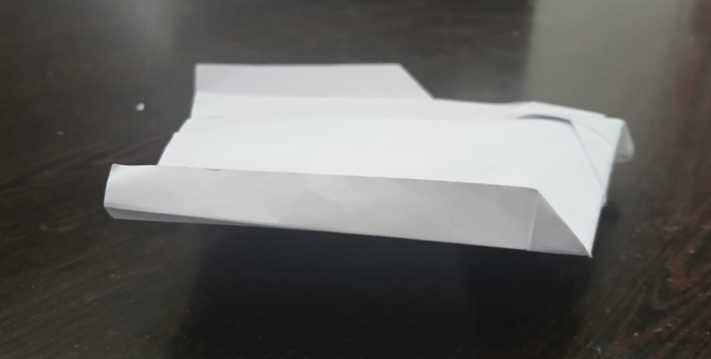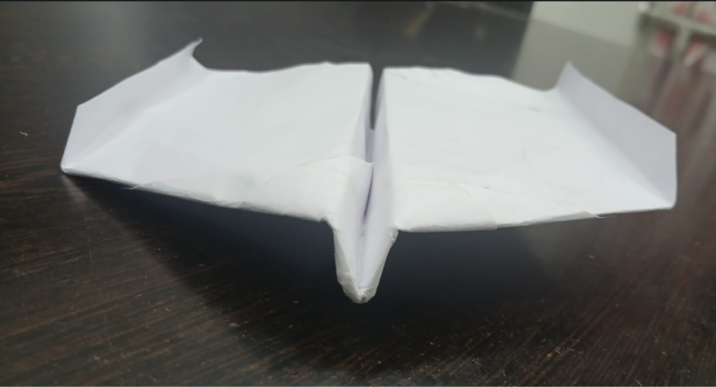

Part C — Experiment
1. Flight Trials and Results
Five flight trials were conducted under approximately similar conditions. The flight duration varied from around 3 to 4.7 seconds, with an average of approximately 4.2 seconds.
Trial | Flight duration (s)
1 | 3.60
2 | 4.20
3 | 4.10
4 | 4.30
5 | 4.65
Average | 4.17
2. Suggested Design Modifications
Modification 1 — Adjust wing angle
- Make a small, equal adjustment to both wingtips.
- Conduct five trials and compare the average flight duration.
Modification 2 — Adjust centre of gravity
- Make a small change to the nose folds to alter weight distribution.
- Test whether the airplane glides more smoothly and remains airborne longer.
3. Controlling Variables
- Use the same launch height and angle.
- Maintain a similar throwing force.
- Test indoors, away from drafts.
- Change only one design feature at a time.
- Conduct five trials for each modified design and compare the average durations.
Conclusion
The airplane remained airborne for approximately 3–4.7 seconds per trial. Adjustments to wing angle and centre of gravity may improve stability and airtime. Further trials are required to determine whether these modifications improve performance

